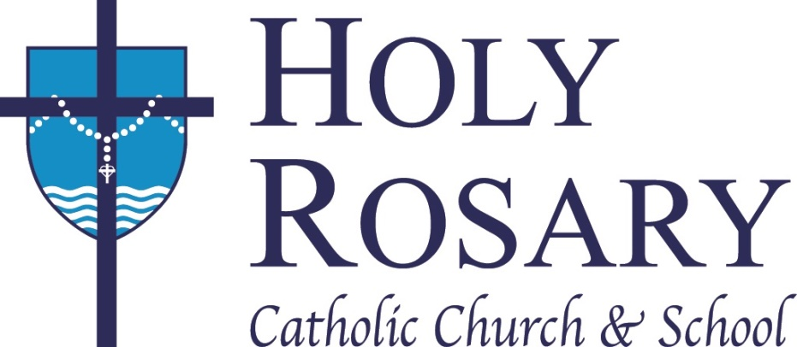

Holy Rosary Trivia

1. The first Mass was celebrated in Kewaunee on Nov 1, 1674 by

Bishop Bona Fr. Marquette Fr. Schmitt Bishop Wycislo

2. Horses used to drink from the springs that flowed out of the hill on Ellis Street. True or False

3. The original Holy Rosary School was completed in the same year as the Peshtigo Fire. True or False

4. How much did the 1963 church and rectory cost?

$650,000 $533,000 $605,000 $1,000,000

5. The school enrollment in 1963 was:
725 415 399 250

6. Who says he cut the grass on the church hill the fastest?

Squirrel Goose Rabbit Wiley Fr. Mike

7. Fr. Mike had an extra bead added to the rosary on the south wall of the gym to pray for:

a successful sports season all parishioners who have left
there isn’t an extra bead those whose minds wandered

8. The furnishings for the 1884 & 1963 churches were created by

Johnson Manufacturing Doerr Woodworking
Svoboda Furniture Bergers

9. The Holy Rosary School song was written by:

Sr. Barbara Ann Marilyn Plos Dorothy Stangel Jen Heidel

