Marriage Preparation Checklist

“The LORD God said: ‘It is not good for the man to be alone.
I will make a helper suited to him.’ ” Gen 2:18

Congratulations!
We are so happy for you as you prepare
to enter into a covenant with each other and God!

Overview of Marriage Prep:
1) Today’s initial meeting with Deacon Chuck and Eileen
-get to know each other
-fill out paperwork
-set up wedding date and time ____________________
*No weddings during Lent or Holy Days
*Ceremony must start on or before 1pm
-discuss overview of marriage prep
-schedule engagement blessing ____________________

2) Engagement blessing at a Saturday evening or Sunday morning Mass.

3) Meeting 2: Discuss In Perfect Union with Deacon Chuck & Eileen. Each of you should write down two things you agree with, two things you disagree with, and two things that you didn’t know before. We will discuss these at a later meeting. http://www.johnpaul2center.org/JohnPaulIICenter/NazarethProject/EngagedEnrichment1/InPerfectUnion-Interactive-Wis.pdf

4) Take FOCCUS premarital inventory. This is a comprehensive survey of areas important in a healthy, happy, permanent marriage. You will receive an email invite to take the inventory. After you complete the inventory, you will be contacted by a FOCCUS facilitator couple from our parish.

5) Meet with parish FOCCUS facilitator couple to discuss inventory (2-3 meetings).

6) Attend two-part diocesan marriage prep classes.

All couples married in the GB Diocese must complete the following marriage prep:
a) Attend a two-part diocesan marriage prep classes. www.marriageinthelord.org
Register early! Please bring back certificate of attendance for your file.
a) Part I: Marriage in the Lord
b) Part II: Natural Family Planning (NFP)

7) Meet with Deacon Chuck and Eileen to review your wedding liturgy.

8) Rehearsal

9) Wedding!!!
Groom: ____________________
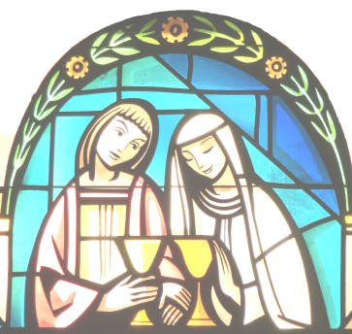
Bride: ____________________
Wedding Date: ____________________

Will dispensation be necessary?
___ Inter-faith Marriage?
___ Groom Prior Marriage?
___ Bride Prior Marriage?

Needed to complete your wedding file:
___ Form A

___ Bride’s B form ___ Groom’s B form

___ Bride’s Baptismal Certificate ___ Groom’s Baptismal Certificate

___ Request for Dispensation (if necessary)

___ Permission from pastor (if not parishioner of Holy Rosary)

___ Bride and Groom’s Premarital Inventory

___ Part I Marriage in the Lord Certificate

___ Part II NFP Certificate

___ Marriage License (see WI state license services website for additional details)

___ A picture of the two of you for the file

___ $75 Church stipend

Together for Life liturgy selections
Old Testament Reading B1-9 _____
Responsorial Psalm C1-7 _____
New Testament Reading D1-13 _____
Gospel F1-10 _____
Exchange of Consent or Wedding Vows H1-2 _____
Prayer of the Faithful J1-3 _____

All songs must be liturgical.

